**Code Optimization Techniques**

Dead code elimination

**Code:**

package deadcode;

import java.util.Vector;

public class DeadCode {

public static void main(String[] args)

{ int a,i=0,b,var2,c=0;

a=4;

b=0;

var2=0;

Vector v= new Vector();

v.add("a=4;\n");

v.add("b=0;\n");

v.add("L1: var2=b;\n");

v.add("if(var2!=0) goto L2;\ngoto L3;" );

v.add("L2: c=a*a;\n" );

v.add("L3: c= a/2;" );

System.out.println(v.get(0));

a=4;

System.out.println(v.get(1));

b=0;

System.out.println(v.get(2));

var2=b;

if ( var2!=0)

{ System.out.println("L2");

c=a*a;

System.out.println(c); }

else

{ System.out.println("L3");

c=a/2;

System.out.println(c); }

System.out.println("Original Code:\n");

for(i=0;i<v.size(); i++)

System.out.println(v.get(i));

v.removeElementAt(3);

v.removeElementAt(3);

System.out.println("Optimised Code:\n");

for(i=0 ;i<v.size(); i++)

System.out.println(v.get(i)); } }

**Output :**

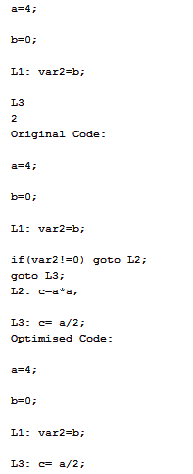

**Strength Reduction**

Program

#include<stdio.h>

void printStmt(char c,char s,int loop)

{

int i = 0;

for(i=0;i<loop;i++)

{

if(i==(loop-1))

{

printf("%c",c);

}

else

{

printf("%c%c",c,s);

}

}

}

void main()

{

int input2,i;

char sign,input1;

float convert;

printf("Enter code in form of arg sign arg\n");

scanf("%c",&input1);

scanf("%c",&sign);

scanf("%d",&input2);

if(sign == '^')

{

printStmt(input1,'*',input2);

}

else if(sign == '*')

{

printStmt(input1,'+',input2);

}

else if(sign == '/')

{

convert = (float) (1/(float) input2);

printf("%c*%f",input1,convert);

}

}

Output

Enter code in form of arg sign arg

x^4

x*x*x*x

Process returned 4 (0x4) execution time : 3.204 s

Press any key to continue.

Enter code in form of arg sign arg

x*3

x+x+x

Process returned 3 (0x3) execution time : 6.851 s

Press any key to continue.

Enter code in form of arg sign arg

x/2

x*0.500000

Process returned 10 (0xA) execution time : 2.720 s

Press any key to continue.